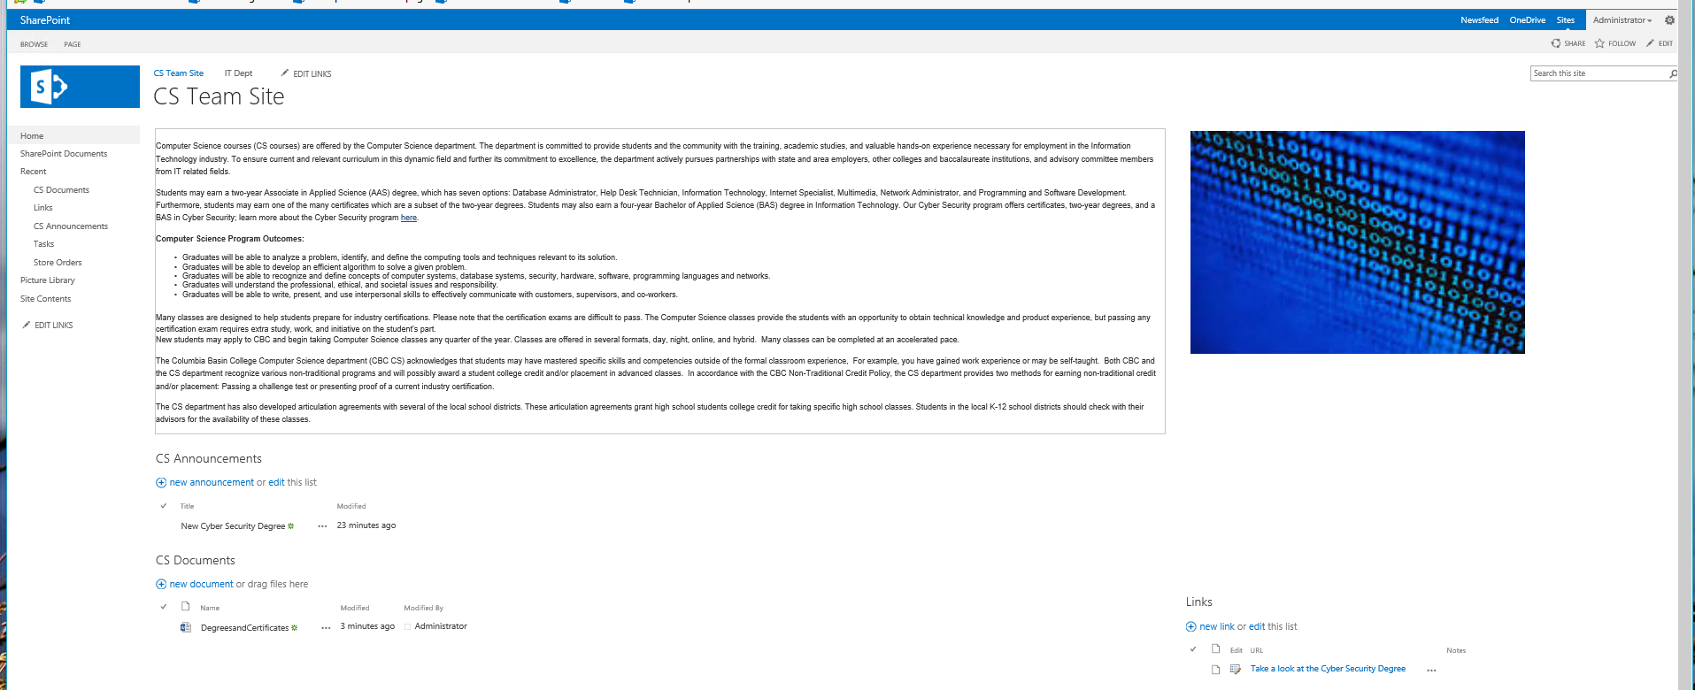Trent Giever

Web Part Assignment

2/7/19